### Direct Messaging in the Provider Directory

Direct Messaging uses the primary direct address associated with each provider to send Direct Messages. It can be accessed from the Application Dashboard or from the **Provider Directory** tab on the *Messaging* screen.



To begin, perform a provider search, and find the desired provider on the result list to the right.

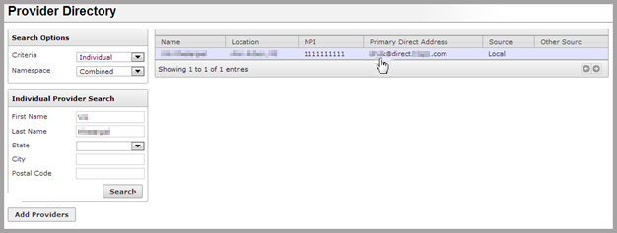

Clicking on the provider’s primary direct address takes you to the **Compose Message** screen, with the provider’s Direct Address auto-populated.